Juan Cardenas
September 13, 2026
Module 1.3 Assignment
1st Screenshot:
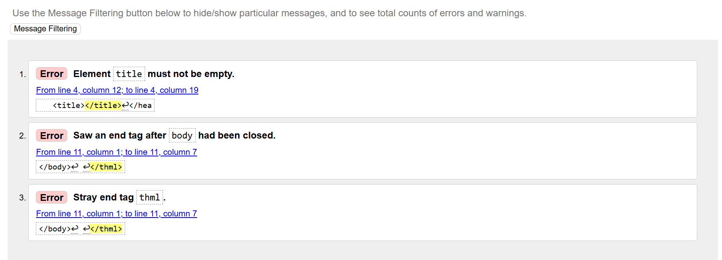
2nd Screenshot:
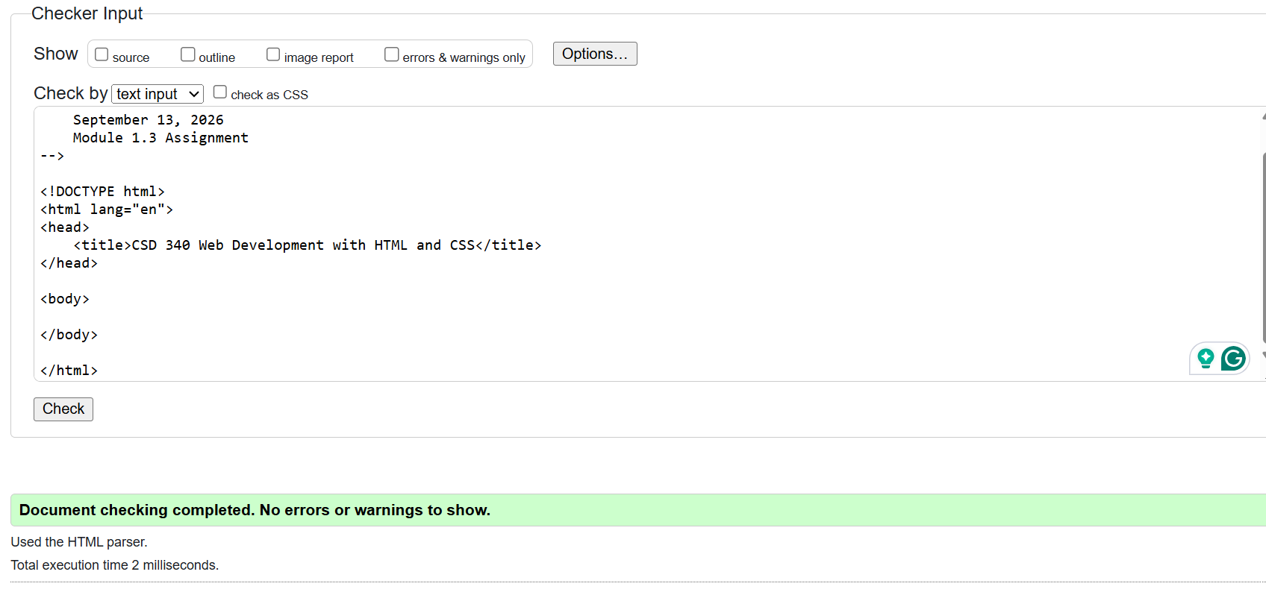

3rd Screenshot:
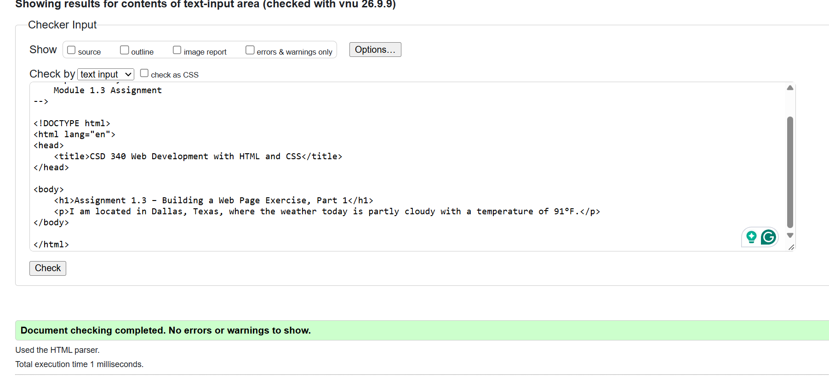
4th Screenshot:
